The Fusion of Chatbots and Augmented Reality for Unparalleled Shopping Experiences

Sitara Khurram

Research Skills,TU Ilmeanu , [sitarah3126@gmail.com](mailto:sitarah3126@gmail.com)

***Abstract*-** **This research paper introduces a transformative approach to revolutionize the online shopping experience through the integration of Next-Generation Smart Mirrors. These cutting-edge mirrors seamlessly blend Augmented Reality (AR) and internet connectivity, featuring an advanced chatbot with natural language processing capabilities. The chatbot engages users in interactive conversations during virtual try-ons, recognizing personal preferences and offering tailored fashion recommendations through sophisticated data analytics. The primary objective is to address limitations in at-home online shopping by virtualizing the try-on process and incorporating post-purchase support elements such as size recommendations and real-time price comparisons.**

***Keywords—Smart Mirror, Price Comparison, Raspberry Pi 3, Mirror.***

## INTRODUCTION

The retail sector is always changing, and there has been a noticeable move towards online buying. Although this shift is convenient, it also highlights enduring issues, especially in the area of internet shopping from home. Customers frequently struggle to sort through the numerous of alternatives available to them and have a hard time of choosing appropriate clothing without the advantage of a real try-on experience and the best prices. These difficulties lead to a significant void in the entire experience of internet buying. The buying process is made less fun when customers must navigate a large range of options without having the opportunity to try them on in person. As a result, customers avoid shopping because they fear making a mistake and avoid trying things out, which results in a decline in customers that requires attention.

In response to this overarching problem, this research proposes an innovative solution— the integration of a chatbot with augmented reality smart mirrors designed specifically for online shopping. This intelligent chatbot serves as a virtual shopping assistant, addressing product inquiries, conducting price comparisons, and offering tailored recommendations. By seamlessly combining the capabilities of a chatbot with augmented reality, this proposed solution aims to redefine the online shopping experience, providing customers with the guidance and confidence they need to make informed and satisfying purchase decisions. The subsequent sections of this paper will explore the technical intricacies and transformative potential of this integration, offering a glimpse into the future of online retail where technology bridges the gap between choice overload and consumer confidence.

## LITERATURE SURVEY

Several solutions exist to address challenges in at-home online shopping, each with its advantages and limitations. Some alternatives include A virtual try-on system based on deep learning,that emphasis is on achieving visually appealing virtual try-ons with high accuracy. This approach not only enhances the visual effects of try-ons but also employs sophisticated techniques, such as predicting semantic layouts and altering reference images for detailed clothing representation.

The Future of Smart Dressing Mirror - an open innovation concept video. Developed by the Lab of Intelligent Computing at Beijing Institute of Technology, this mirror digitizes clothing, employs machine learning, and utilizes computer vision technologies. It offers interactive features, recommends fashionable clothing combinations, and even facilitates e-shopping directly through the mirror interface, providing a futuristic solution to the daily dilemma of choosing the right outfit.

Marker-less Augmented Reality based application for E-Commerce to Visualize 3D Content.

These innovations not only aim to enhance the virtual try-on experience but also address common challenges in online shopping, such as decision-making difficulties and the need for personalized, interactive solutions. The synthesis of these studies lays the groundwork for understanding the potential impact of Fusion of Chat-bots and Augmented Reality on the online shopping landscape.

Into 3D-Reconstructed Apparel over Virtual Try-On with Virtual Reality this research addresses the limitations of traditional 2D image views in online shopping, augmented reality emerges as a transformative solution. By combining the real world with the virtual, AR in e-commerce allows customers to visualize products in their physical space before making a purchase. This approach aims to streamline decision-making by allowing users to try out garments virtually, both off-the-shelf and custom, without hindrance.

The mentioned research papers contribute valuable insights to the field of augmented reality (AR) in e-commerce, they are considered insufficient because of few factors like Limited Focus on Post-Purchase Support, Inadequate Real-Time Price Comparisons.

Enhancing the creative idea of The Fusion of Chatbots and Augmented Reality this paper introduces several key enhancements that significantly elevate the user experience, providing a superior and more comprehensive solution to the common challenge of deciding what to wear.

Central to the mirror's capabilities is its advanced chatbot, equipped with natural language processing (NLP) to address user inquiries comprehensively. The chatbot not only provides assistance during the virtual try-on process but also serves as a knowledgeable companion throughout the user's journey. Users can ask questions about product details, materials, and care instructions, receiving instant and accurate responses including size recommendations, information regarding shipping fostering confidence in their purchasing decisions. It can also suggest complementary items or alternatives based on the user’s feedback.

The present collection of research is unable to offer dynamic and real-time price comparison services, potentially limiting users' ability to make informed decisions based on the most current information.

One notable enhancement this paper provides over existing smart mirrors is the integration of real-time price comparison capabilities with the help of chatbot. The mirror scans various e-commerce platforms to provide users with a comprehensive overview of the prices for a chosen product. This feature empowers consumers to make informed decisions, ensuring they secure the best possible deal without the hassle of manually searching multiple websites.

## PROPOSED METHODOLOGY

The chatbot employs a multifaceted approach to engage users within the virtual shopping experience. Initially, motion sensors detect user presence, triggering the chatbot's activation. Once initiated, the chatbot introduces itself in a user-friendly manner, presenting a range of assistance options, including virtual try-ons, product inquiries, and style recommendations.

For virtual try-ons, the chatbot employs step-by-step guidance, leveraging advanced algorithms to showcase diverse styles, provide tailored suggestions, and offer real-time feedback on the user's virtual appearance. This process involves intricate backend processes, including image recognition and rendering algorithms to ensure a seamless and realistic virtual try-on experience.

In the case of product inquiries, users can interact with the chatbot to obtain specific details or personalized recommendations. The chatbot accesses its extensive database, utilizing natural language processing algorithms to comprehend user queries and deliver accurate information promptly. Machine learning models may also play a role in continuously refining the chatbot's ability to understand and respond to user inquiries effectively.

Throughout the user interaction, the chatbot employs sophisticated algorithms for decision-making support, enhancing the user's understanding of available products and facilitating informed choices. The seamless integration of these methods not only augments the virtual shopping journey but also underscores the technical complexity and adaptability of the chatbot in catering to diverse user needs. When users select an outfit, the mirror swiftly initiates a real-time price comparison by employing sophisticated algorithms that dynamically scan various e-commerce platforms. Utilizing machine learning algorithms and web scraping techniques, the smart mirror systematically extracts relevant product information from different online sites.

The system employs a product matching algorithm to identify identical or closely similar items across platforms, ensuring accuracy in comparing prices. Additionally, a price tracking algorithm continuously updates the displayed prices to reflect the most recent information available.

The user interface of the smart mirror is designed to present the results in a structured manner, displaying not only the matched products but also their corresponding prices and links to the original listings on respective e-commerce sites. This technical approach enhances the transparency of the comparison process, providing users with a detailed and real-time analysis of product pricing across multiple platforms.

A. *Architecture*

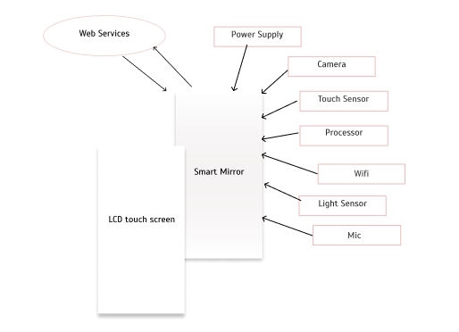

Fig 3.1 Block diagram

## HARDWARE

1. -The Smart Mirror combines a sophisticated 32-inch LCD display with an interactive touch surface. Its dimensions, at 40 inches by 24 inches, provide an optimal balance between usability and aesthetics
2. Input Devices: - The mirror employs an array of touch sensors, and microphone enabling users to interact intuitively with the interface. These sensors facilitate a seamless and inclusive user experience.
3. Camera System: - Equipped with a high-resolution camera system featuring 1080p resolution and a wide-angle lens, the smart mirror enhances virtual try-on experiences and augments the functionality of the integrated chatbot for personalized interactions.
4. Display Technology: - The smart mirror utilizes an LED-backlit LCD display with a resolution of 1920 x 1080 pixels, providing crisp and clear visuals. The display technology ensures accurate representation of clothing items for virtual try-ons.
5. Processing Unit: - Powered by a robust quad-core processor, the mirror's processing unit handles real-time image processing, machine learning tasks, and supports the integration of advanced functionalities of chatbot.
6. Connectivity: - With Wi-Fi connectivity, the smart mirror establishes a seamless connection to e-commerce platforms for real-time price comparison.
7. Power Supply: - The mirror operates on standard electrical power, ensuring continuous functionality.

## PROCESS FLOW

User approaches the Smart Mirror.

1. User Engagement:

Motion sensors detect user presence.

1. Interface Interaction:

Users interact with the mirror using touch gestures or voice commands.

1. Virtual Try-On:

Users choose the "Virtual Try-On" option.

Camera captures real-time images for virtual try-ons.

1. Chatbot Interaction:

Chatbot engages in real-time.

Users ask questions, receive style recommendations.

1. Real-Time Price Comparison:

Users select an outfit.

Mirror scans e-commerce platforms for real-time price comparison.

1. E-Shopping Integration:

Users can access to e-shopping directly through the mirror.

Browse, select, and purchase items.

1. Size Recommendations and Post-Purchase Support:

Mirror provides size recommendations based on historical data.

Offers post-purchase support for personalized assistance.

1. Checkout and Payment:

Secure checkout process initiated.

Users review selections, input payment details, and place orders.

1. Delivery Information:

Mirror displays order history.

Users track the status of deliveries.

1. End:

Shopping process concludes.

## REAL TIME COMPARISION MODULE

In the user interaction phase, individuals engage with the smart mirror, utilizing functionalities such as virtual clothing try-ons and apparel exploration. This interaction is facilitated by the Chatbot and User Interface Module, serving as intermediaries to the Real-Time Price Comparison Module. At the system's core, the Real-Time Price Comparison Module operates through a series of intricately designed processes.

The E-Commerce Platforms Integration Module establishes crucial API connections with various e-commerce platforms to retrieve the most current data. Following this, the Product Identification and Price Data Retrieval process leverages advanced web scraping techniques and machine learning algorithms to pinpoint specific products and extract real-time pricing information from the connected platforms.

To ensure data consistency and coherence, the Data Normalization step employs statistical methods and data formatting techniques, standardizing pricing data formats across different e-commerce platforms. Subsequently, the Comparison Algorithm & Selection component utilizes advanced statistical models, possibly incorporating machine learning algorithms, to analyze the normalized data. This analysis culminates in the selection of the e-commerce platform offering the most favorable price based on predetermined criteria.

The Display Results to User module utilizes a sophisticated user interface, presenting these price comparison outcomes through the smart mirror interface. The User Confirmation & Integration with E-Shopping ensures a seamless transition for users to initiate the purchasing process, integrating with e-commerce platforms for secure and user-friendly transactions. 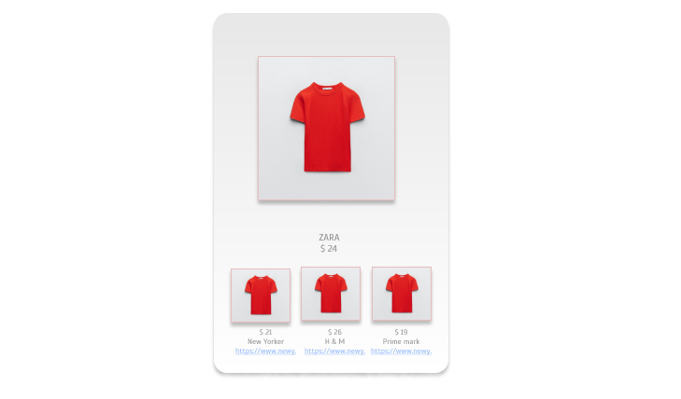

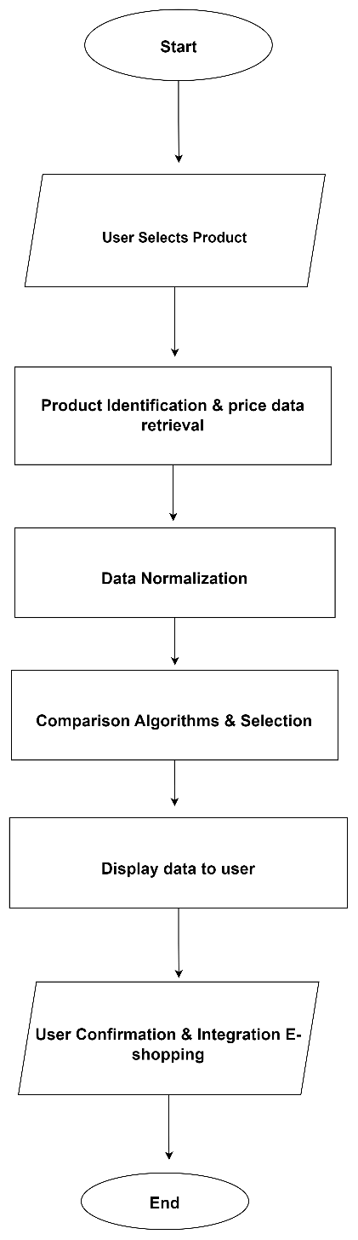

Fig 6.1 Data flow diagram

## CONCLUSION

The integration of a chatbot with augmented reality smart mirrors revolutionizes the online shopping landscape. The system, characterized by dynamic user engagement, real-time price comparison, and seamless e-shopping integration, addresses challenges like choice overload and customer apprehension. Technically, advanced algorithms, web scraping, and statistical models power modules such as E-Commerce Platforms Integration, Product Identification, Data Normalization, and Comparison Algorithm & Selection. The system's sophisticated user interface enhances visual representation, ensuring a user-friendly and secure purchasing experience. This innovative smart mirror system not only overcomes challenges in online shopping but also empowers users with real-time information and personalized recommendations, creating a dynamic and enjoyable online retail experience.

# REFERENCES

1. Guangyu Gao, Chenchen Bai, Wei Zheng and Chi Harold Liu,” The Future of Smart Dressing Mirror - an open innovation concept video”, 2015 IEEE.
2. Yashvi Desai, Vrushali Shah, Dr. Prasenjit Bhavathankar, Prof. Kaisar Katchi. Department Of Information Technology “Markerless Augmented Reality based application for E-Commerce to Visualise 3D Content”, 2021 IEEE
3. Jianhua Hu, Weimei Wu, Mengjun Ding, Xi Huang, Xuankai Li, zhi jian Deng. Department Of Information Technology “A virtual try-on system based on deep learning”, 2023 IEEE
4. Surasachai Doungtap, Jirayu Petchhan, Varinya Phanichraksaphong, Jenq-Haur Wang,. International Graduate Program of Electrical Engineering and Computer Science “Into 3D-Reconstructed Apparel over Virtual Try-On with Virtual Reality”, 2023 IEEE

Home”,International Journal On Advances In Intelligent Systems,Vol.9 no 1 & 2,2016.

1. D. Besserer , “Fit Mirror: A Smart Mirror For Positive Affect,In Everyday User Morning Routines, Proceedings of the Workshop on Multimodal Analyses Enabling Artificial In Human Machine Interaction, November2016.
2. S.Colantonio ,”A Smart Mirror TO Promote A Healthy Lifestyle”,Biosystem Engineering vol.138,pp 33- 43,October 2015
3. Y.Andreu Cabedo ,”Mirror On the Wall;An Intelligent Multisensory Mirror For Well being Self Assessment”, International Conference On Multimedia And Expo(ICME), IEEE,July 2015.

[10] D.Morberg and M.Ekstrom,Master thesis ,” Sensor System For Spinal Injury Risk Reduction”

,Malardalen University,June 2016.

1. Suryansh Chandel ,Ashay Mandwarya, S. Ushasukhanya ,”Implementation Of Magic Mirror Using Raspberry Pi 3”,International Journa Of Pure And Applied Mathematics Vol 118 no. 22,2018,451-455 ISSN:1314-3395.
2. Mayur Wani, Prashant Ahire,”Smart Mirror System Using Internet On Things”, IJAERD.January 2019,
3. Prajakata Gavare,Prashant Ahire, “Big Data Classification Of User Navigation And Behavior Using WebServer Logs”, 10.1109/ICCUBEA.2018.8697606.
4. Swati.C.Dandekar, Prashant Ahire, Jyoti Rao, “Improved Secret Information Hiding Using SHA-

256 AND Invisible ASCII Character Replacement Technology”.10

(abc, 2020)